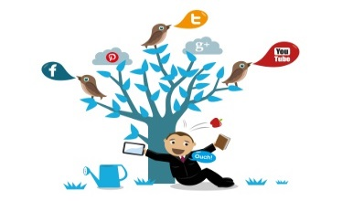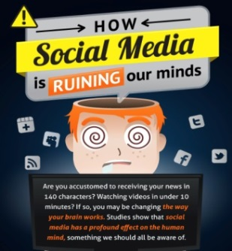

**The Like button became a major issue in our lives.**

**Social networks have become so ugly that they will be the #1 source of malware infections.**

**Most people are now one step removed from reality as the world shifts to sharing moments rather than experiencing them.**



**We have heard how some videos or pictures of teenagers go viral on social media sites and how it mentally hurts everybody involved.**

**It is very easy to gain access to social networking. It is free and fast. Once you gain access to the social site, you can begin to co-mingle; you can read profile pages of the friend-members and you can start searching for old friends – even the long lost ones.**

**An account holder in a website should be very cautious. The platform will not be free from scammers.**

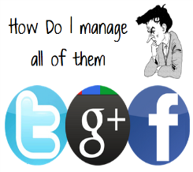

**The best way to avoid becoming a victim is to be very careful in what you put in your profile and also, safeguard the setting of your account.**

**Finding friends may be one of the most important impacts of social media. You can easily send messages, chat or connect to more people without any cost. As more users are frequent visitors, you are assured that your message will reach the person soon as he or she logs in to his or her account.**

**Many admit they have missed important moments in person because they were too busy trying to share those moments on social networks.**

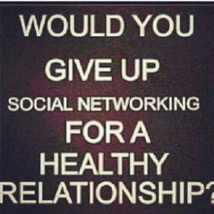

**People are able to stay in touch with family and friends. Even older generation has taken to social media** **to keep in touch with their children and family living far.**

**Celebrities, politicians, employers can all reach out to the public via social media sites to post updates, announce events etc.**

**It is effective for anybody to share news, useful info, gossip, what’s in and what’s hot.**

**Social networks have become the ultimate means of promoting your web site.**

**They are great ways to attract an audience and expand your client base.**

**Social networks can have a negative influence on worker productivity. Employees may waste valuable time using social network channels.**



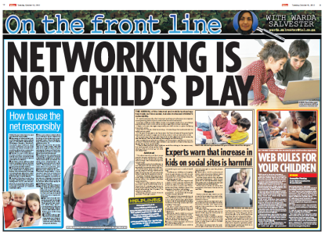

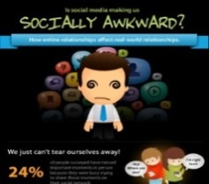

**Use of social networks can expose individuals to harassment or inappropriate contact from others.**

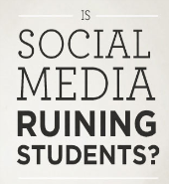

**Today, online social networking became the fastest and cost-effective way on how people get-together.**

**A common complaint among educators is that social media is distracting in the classroom.**

**With the advancements in technology and the evolution of social media, your business now has the ability to be connected to its audience like never before.**

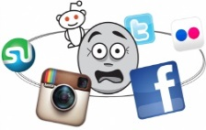

**There is lack of privacy, which leads to security concerns such as Identity theft. When information such as name, birth date, address, mother’s maiden name, children’s name, pets etc is available to all, then users are basically calling for trouble.**

**Now, answer the following questions.**

1. **Is online socializing having an impact on our offline lives? And is the impact across the globe equally felt?**
2. **Are we so busy making new friends and spending time with them online that we are failing to nurture real-world friendships the old fashioned way?**
3. **Is how we socialize online eroding our real-life relationships? Or maybe just changing them?”**
4. **Which pros and cons of social media can you identify in these paragraphs?**
5. **Can you point out any other?**

**Shopping is also much more interesting. We can instantly read reviews about products, locations, places to stay etc. online with the help of social media.  People also get readymade and suggested itineraries for places they plan to visit!**

**Research has shown that rise in social media is directly correlated to adverse reactions in health. Being online most of the time has taken people away from going out to communicate and keeping in touch.**

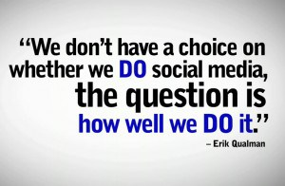

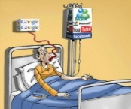

**Are you a fan of instant communication as a result of social media?**

**Social media is becoming an addiction.**

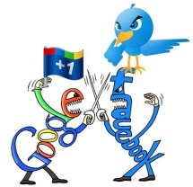

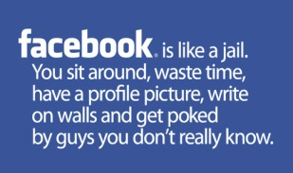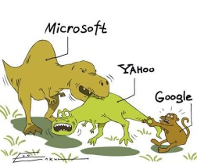

**Shy and social introverts find a place for themselves in social media. They can avoid face to face communication and still be active socially. It increases their confidence and they no longer have to feel left out.**

**Speaking practice questions to consider**

1. Is social media popular in your country?
2. How much time do you spend on social media every day?
3. [Do you lead an Instagram lifestyle?](https://eslbrains.com/are-you-living-an-insta-lie/)
4. Why do some people choose not to use social media?
5. What is your favorite social media platform?
6. What are your thoughts on the role of social media in today's world?
7. What do you think social media will be like in the future?
8. If you could change one thing about social media, what would it be?
9. Have you ever had a negative experience with social media?
10. Do you think people should be more careful about what they share online?
11. What do you think is the most positive thing about social media? And the most negative?
12. How do you use social media in your everyday life?
13. What effect do social networking sites have on the way people communicate?
14. How will social media evolve in the future?
15. Do you know anyone who has a problem with social media addiction?
16. Have you ever taken a break from social media?
17. Do you ever worry about what information social media companies have on you?
18. Do you think people should be more aware of the privacy settings on social media platforms?
19. What do you think about the way social media is used in marketing and advertising?
20. Do you think social media is having a positive or negative effect on our emotional health?
21. What do you think of social media's influence on free speech?
22. What do you think about the way social media is used in politics?
23. What are your thoughts on the role of social media in today's world?
24. What do older members of your family think about social media?
25. Do you think social media is making us more or less connected to each other?
26. Do you think social media is desensitizing us to violence and other disturbing content?
27. Do you have any concerns about the way social media is impacting our privacy?

**Vocabulary related to social media**

|  |  |  |
| --- | --- | --- |
| * to accept / reject a friend request * to check your newsfeed / notifications / timeline / updates * to quit social media * to tag someone in a photograph * to access / delete / have an account * to update your status / your profile | * to have a freedom to be whatever you like * to download a podcast * to express oneself * to share one’s opinion * to get a feedback * to keep in touch with smb * to stay always connected * to spy on smb | * to unfriend somebody * to send a friend request * to be addicted to social media * to post something on the page * to share / hide / report / like a post * to create a different identity |

*Vlog* = a video blog

*Emoticon /ɪˈməʊtɪkɒn/* =a short sequence of keyboard letters and symbols, usually emulating a facial expression, that complements a text message.

*Vlogger* = a person who creates a vlog

*Twitterati* = users on Twitter with an incredibly large number of followers

*Influencers* = famous personalities in social media

*Hater* = someone who voices negative opinions about other people

*Troll* = a person who deliberately starts arguments in comments

*Story* = photos and videos that are compiled into an album that is visible only for 24h

*Share* = number of times a content has been reposted

*Impression* = number of times someone’s post has been seen by other users

*Handle* (@) = user’s account name on social platforms

*Hashtag* (#) = word or phrase used to find content about a specific topic

*AMA* = ‘ask me anything’ session to answer any question people ask

*Blogosphere* = when bloggers are discussing the same issue, this issue is ‘in the blogosphere’

*Clickbait* = headlines that make a person want to click the link to read an article

*Meme* = a funny picture with text on it

*Filters* = user’s way to edit photos

*Lens* = animated overlay effect used for a selfie

*Livecast or (live) streaming* = online streaming media simultaneously recorded and broadcast in real time

*Go viral* = when something popular spreads quickly